MIDTERM EXAM
GEE 007: GENDER AND SOCIETY
NAME:__________________________________________________________________________________ DATE:____________________
COURSE, YEAR & SECTION:__________________________________________________________________

TEST II: MULTIPLE CHOICE. Shade your answer on the answer sheet. NO ERASURES.
- AJ is born with female reproductive organs. Her parents need to fill out the form in her birth certificate. They should put "____" in the box below "Sex"
- Sex c. Gender
- Sexuality d. None of the above
- A person wearing clothes, behaving and thinking like the opposite gender is called a _________.
- Transwoman c. Transman
- Transgender d. All of the above
- The origin of women’s oppression in society stemmed from the concept of ______.
- Patriarchy c. Feminism
- Paternalism d. None of the above
- In what ancient civilization do women have a higher status than men?
- Greek c. Egypt
- China d. None of the above
- In China, a widowed mother should obey her ______.
- Father c. Husband
- Son d. New Husband
- Menstrual cycle marks the beginning of puberty for women.
- Circumcision c. Menstruation
- All of the above d. None of the above
- The loose foreskin at the tip of the penis is _______.
- Prepuce c. Perenium
- Pacemaker d. None of the above
- The most effective method of contraception.
- Sterilization c. Withdrawal
- Calendar d. IUD
- People should need drugs to cope with problems and disappointments.
- True c. All of the above
- False d. None of the above
- A drug commonly grown in tropical countries like the Philippines. It is commonly called weed.
- Marijuana c. Mariana
- Mairungi d. None of the above
- In the triangular theory of love, what is the most important component. Without this, the relationship will not work.
- Intimacy c. Commitment
- Passion d. None of the above
- Love is not a universal experience. Not all can experience love.
- True c. All of the above
- False d. None of the above
- According to the color wheel of love, the love for parents and siblings is called _____.
- Philia c. Storge
- Agape d. Philautia
- This is an abnormal sexual behavior that involves getting sexual aroused with seeing feet or other non-sexual things.
- Frotteurism c. Masochism
- Voyeurism d. Fetishism
- This concept of masculinity proposes that men are able to adopt what is viewed as traditionally feminine characteristics.
- Protest Masculinity c. Collective Masculinity
- Caring Masculinity d. None of the above
- This Republic Act is primarily enacted to protect women and their children against any form of violence.

- RA 7877
- RA 9262
- RA 8353
- RA 10354

- Juniboy and Byen first met in a karinderya. They were attracted to each other instantly. Juniboy went to say “hi” to Byen and asked for her number. According to George Levinger, Juniboy and Byen are in what stage of relationship?
- Build-up c. Acquaintance
- Consolidation d. Decline
- What among the choices is the most ineffective method of contraception?
- Withdrawal c. Sterilization
- Birth Control Injections d. Implants
- Leonard can’t control his fascination of going to female public toilets and secretly watch women as they pee. He is doing __.
- Voyeurism c. Frotteurism
- Masochism d. Exhibitionism

- Rita, from a b’laan tribe, attends college in the city. On the first day, she observed other students looking at her differently. The next day, she heard comments about her hair and her smell. Then the next day, all students avoided her and she’s alone all the time. What is Rita experiencing?
- Stereotype c. Prejudice
- Sexism d. Discrimination
- In Greeks, male to younger male lovers are common. For them homosexual relationship is called___.
- Pederasty c. Peredasy
- Peeradasy d. None of the above
- Sheena was born female. Growing up she doesn’t get attracted to anyone. She would say that she is ___.
- Bisexual c. Intersex
- Asexual d. Transexual
- Johny was born male. He grew up behaving and dressing up masculine. He would say he is “straight”. When the gender identity matches with the sex one is born with. This is called ____.
- Cisgender c. Homosexual
- Heterosexual d. Cisexual
- This is issued for the purpose of preventing further acts of violence against a woman and her child after they complain of VAWC.
- VAWC Desk Order c. Restraining order
- Protection Order d. All of the above

- The boyfriend has bouts of extreme jealousy to the point where he follows her girlfriend in her house, office and even inside a public cr. The girlfriend got so uncomfortable with this. She can site which line from VAWC?

- Causing substantial emotional or psychological distress to the woman such as stalking.
- Preventing the woman from engaging in any legitimate profession, occupation, business or activity
- Rape, sexual harassment, acts of lasciviousness, treating a woman as a sex object
- All of the above

- Cath went to a party with her friends. She drank too much and one of her male friends checked her in a hotel at 11pm. The male friend left the hotel at 4am. The following day Cath woke up without recollection of the whole night. 3 months later, she found out she's pregnant. She investigated and found the records on the hotel. Can she file a case of rape against her male friend?

- Yes, because she was unconscious when he took advantage of her. She did not give him consent.
- No, because she should have filed the case earlier.
- Yes, because the records of the hotel can clearly prove that her male friend sexually abuse her.
- None of the above

- According to this theory of sexual harassment, men have naturally more sex drive than women thus they like to touch, watch and do sexual acts

- Natural/Biological Theory c. Sex Role Spill-over theory
- Feminist Theory d. Organizational Theory

- In RA 8353, what clause states that when a victim marries her rapist, this dissolves the case of rape?
- Forgiveness Clause c. Freedom Clause
- Feeling Clause d. None of the Above
- Member of the LGBTQIA+ community are frequently discriminated in this place because of certain bible verses that prohibits homosexuality.
- Church c. Work
- Military d. none of the above

- Blocking a woman's path, indecent offers, groping and cat calling is a form of ____.

- Pornography
- Sexual Harassment
- Sexual Exploitation
- None of the above

Test III. Case Studies (10 pts. Each)

State your stand on the following cases. Name the victim/survivor (2pts) and the perpetrator (2pts), law/laws (complete and not abbreviated) violated (2 pts) and explain how the perpetrator violated the law. In the explanation, you have to state why you think the law was violated and how did the perpetrator do it (4pts).

Case 1: Loisa, an 8 year old gay, live in a highly conservative household. He wears make up and put on his mother’s dresses. One day, his father Mando , a police officer, saw Loisa wearing lipstick, he immediately punched and dunked Loisa’s head in a tub of water. Loisa almost drowned. He had a broken nose.
VICTIM/SURVIVOR
PERPETRATOR
LAW/LAWS VIOLATED
EXPLAIN HOW THE PERPETRATOR VIOLATED THE LAW
Case 2: Jane. 30, wife of John, went to the police to complain. 2 weeks after normally delivering a baby, Jane’s husband forced her to have sex. Jane did not consent but she was unable to refuse since she is still recovering from giving birth. The police just sent Jane home to “talk it out with her husband”. The next day, Jane reported back to the police and said she will not file a case because she already forgave her husband. Before leaving the station, the police noticed Jane’s eye was swollen and her left hand was seemingly dislocated.
VICTIM/SURVIVOR
PERPETRATOR
LAW/LAWS VIOLATED
EXPLAIN HOW THE PERPETRATOR VIOLATED THE LAW
Case 3. Jiniper, female, 25 years old, applied for a job at AB Digital Tech, a company specializing in computers and technology. During the interview, the all-male panelist commented they might not hire Jiniper because she is a female and the company is dominantly having male employees. Jiniper insisted that she can do what men can do. One panelist, the C.E.O, then said, “Ok, we will hire you if you promise to wear heels and sexy skirts everyday” (laughs). Jiniper agreed because she needed the job and she was hired the next day.
VICTIM/SURVIVOR
PERPETRATOR
LAW/LAWS VIOLATED
EXPLAIN HOW THE PERPETRATOR VIOLATED THE LAW

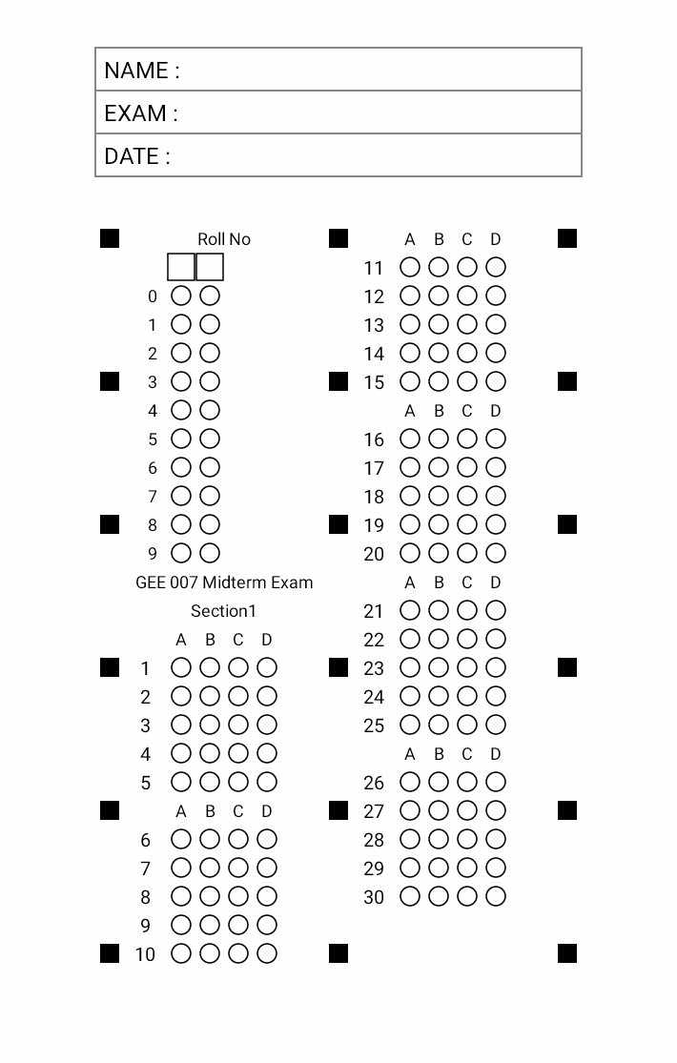
GENDER AND SOCIETY

